**1. Introduction**

**1.1 Purpose**

The purpose of this website is to sell Egyptian handicrafts, showcasing the artistry and craftsmanship of Egyptian culture. It provides a platform for artisans to present their work online and enables customers to explore and purchase authentic handcrafted items.

**1.2 Goals**

Promote Egyptian Handicrafts Globally: Showcase the rich cultural heritage of Egypt to an international audience.

Facilitate the Selling Process for Tourists: Provide an easy-to-use platform for tourists to purchase souvenirs and crafts, even after leaving Egypt.

Support Local Artisans: Create an additional income stream for artisans by expanding their market reach.

**1.3 Technology Stack**

The following programming languages and frameworks were used in building the website:

HTML: Structure of the web pages.

CSS: Styling and layout.

JavaScript: Dynamic functionality and interactivity.

TypeScript: Enhanced JavaScript with type safety.

Angular: Framework for building scalable and responsive web applications.

**2. Setup Instructions**

**2.1 Prerequisites**

To access and use the website, users only need:

A device with an internet connection (PC, tablet, or smartphone).

A modern web browser (e.g., Chrome, Firefox, Safari).

**2.2 Sign-Up / Sign-In**

Using the website requires a simple registration process:

1. Sign Up:

Provide a valid email address.

Create a password.

Confirm your password.

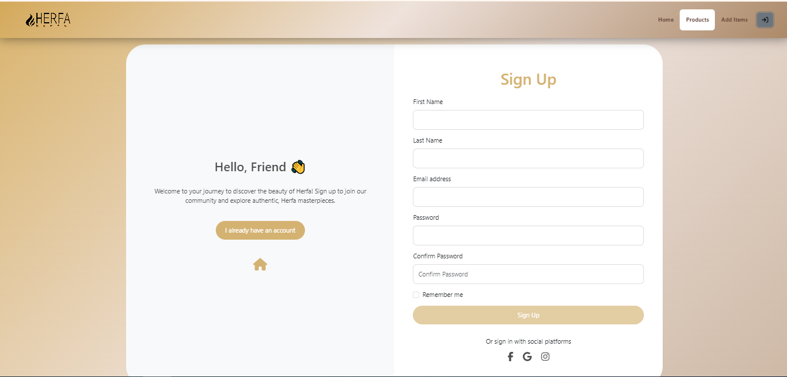



2. Sign In:

Use the registered email and password to log in.

If you forget your password, you can reset it using the "Forgot Password" option.

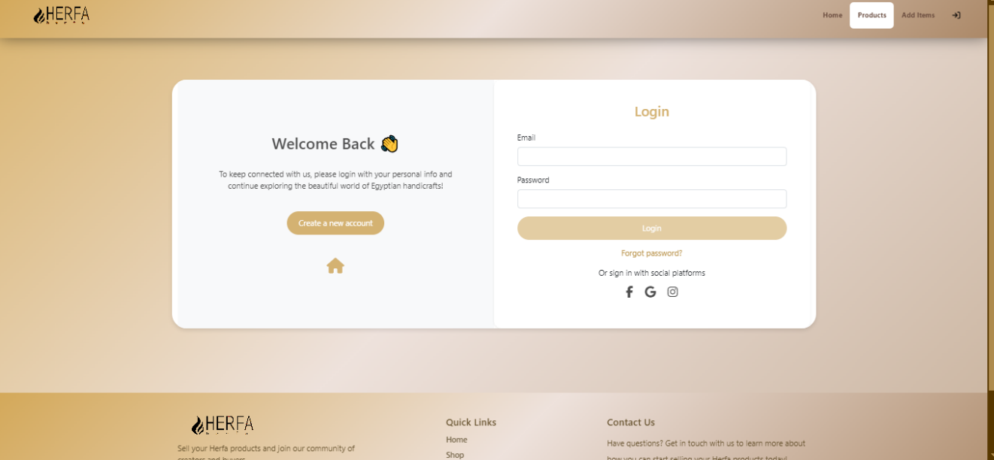

**2.3 Access Without Installation**

No installation or software downloads are required. The entire website is accessible via the browser.

**3. Usage Instructions**

**3.1 Determine Your Role**

The website offers two main user roles: Trader and Customer. Upon signing up, you will need to select your role to unlock relevant features

**3.2 For Traders**

If you choose the Trader role, you will have access to features designed to help you showcase and sell your products.

1. Add New Products:

Provide product details (name, description, price, and images).

Indicate whether the product has a discount.

2. Manage Inventory:

Edit product information or remove items that are no longer available.

Track the status of your listed items (e.g., sold or available).

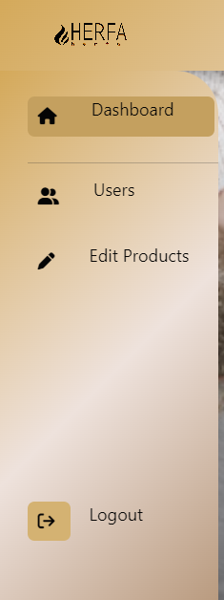

3. View Orders:

Check customer orders and prepare shipments.

Update order statuses (e.g., processing, shipped).

4. Analytics Dashboard (if available):

Track sales performance and product views.

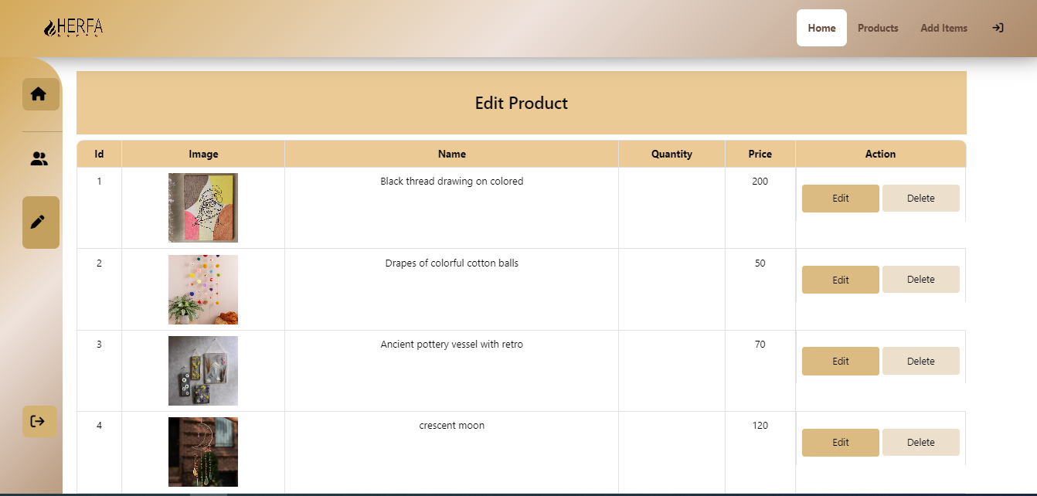

**3.3 For Customers**

If you select the Customer role, you will be able to browse and purchase products seamlessly.

1. Browse Products:

Explore different categories of Egyptian handcrafts.

Use filters to search for specific products or discounts.

2. Add Products to Cart:

Select the quantity of desired products and add them to the cart.

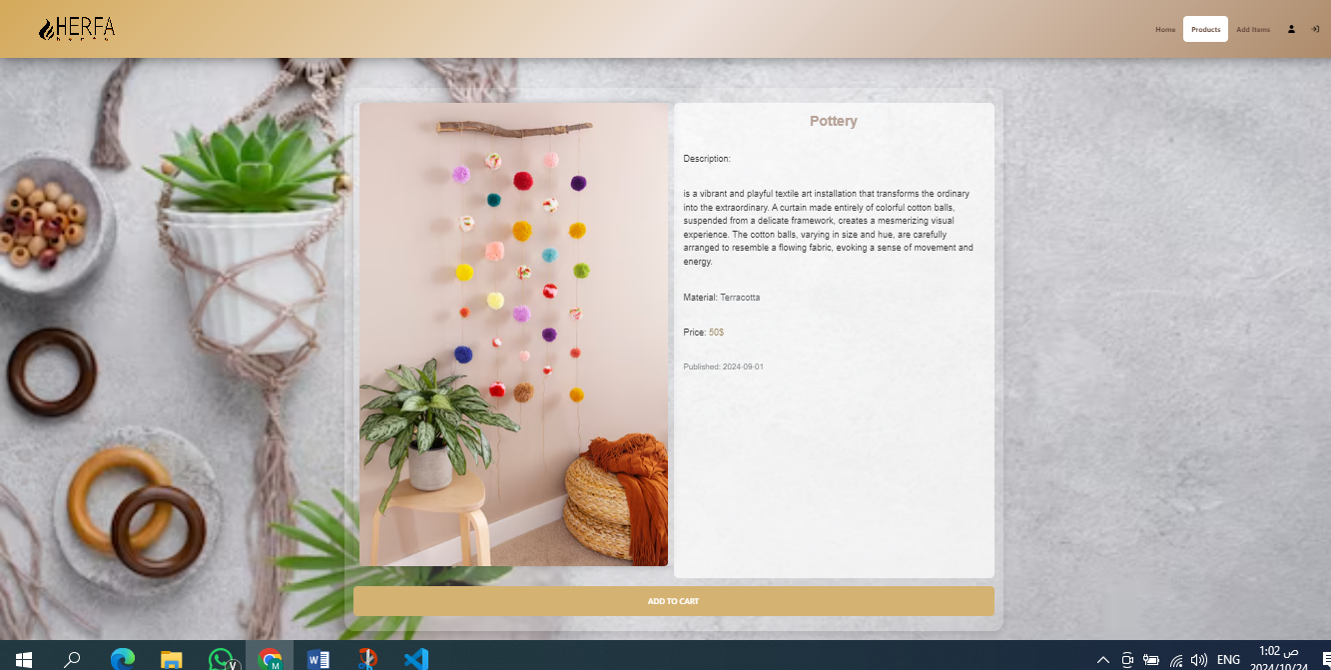

3. Place Orders:

Proceed to checkout and provide your shipping details.

Choose your preferred payment method (if available).

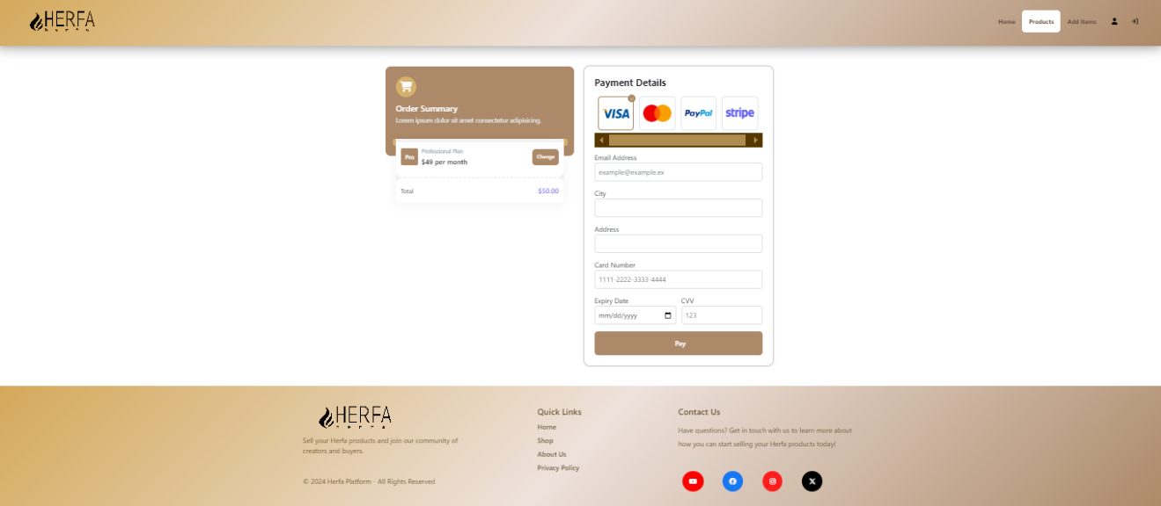

4. Leave Reviews:

Share feedback by reviewing purchased products